Reflections from the field: Jordan
By Aimée Keay
“Peace means that we live with lasting freedom,” Awatif.
The desire for safety, peace and belonging is universal. For millions of people in Jordan, it has shaped generations of hopes for security, home and a future for their families.
For Awatif, that dream of freedom is shaped by a history of displacement. She’s lived her whole life in refugee camps – first in tents, then mud huts and now a block-built house.
“My family suffered a lot through the experience of [seeking] refuge. They moved from place to place, almost walking all the way from Gaza to Jordan when they were displaced and arrived.”
Jordan has long been a safe haven for millions of people displaced by conflict in the Middle East.
Jordan hosts one of the world’s largest refugee populations relative to its size, including more than 2.3 million Palestinian refugees. Many Palestinians who arrived after the major conflicts in 1948 and 1967 now hold Jordanian citizenship. Others retain their refugee status, holding onto their connection to their Palestinian identity and the hope — however uncertain — of one day returning home.
Hundreds of thousands of Syrians also remain in Jordan where return is still uncertain or unsafe
And thousands more from Iraq have also sought refuge and asylum in Jordan.
I recently travelled to Jordan to spend some time with Act for Peace’s local partner, Department of Service to Palestinian Refugees (DSPR) and meet with community members who are part of the Forsa program.
During my visit, I had the privilege of hearing from Palestinian and Syrian refugees and local Jordanian families. Some had completed the two-year Forsa program and shared how it had helped them build new skills, livelihoods and connections. Others were just beginning, speaking with hope and determination about the possibilities ahead and the future they want to build for themselves and their families.
Forsa (which means ‘opportunity’ in Arabic) is a holistic program that supports Syrian and Palestinian refugee families build sustainable livelihoods and greater self-reliance through skills development, confidence and ongoing mentoring.
The program also engages Jordanian host community families who are facing significant financial hardship, strengthening relationships and social cohesion across communities. Forsa is shaped by people who know these communities well and whose trusted relationships make lasting change possible.
This program combines practical training, mentoring and community-based protection activities across three key areas:
- Life skills and vocational training: building confidence, communication, and technical skills for employment or small business creation.
- Financial inclusion: helping families to budget, save, and access safe digital payment systems.
- Community empowerment: strengthening protection mechanisms, social cohesion, and leadership within refugee communities.
When I met Dalal and Abdullah, they shared some of the emotional and social impact of displacement. While they had found safety in Jordan, leaving their family and home behind in Syria came at a high cost.
“It’s so hard that I left my country and came here to the camp and stayed for three months, and I left my family there… I left my home and my family, my brothers, my sisters, my mother and my father,” says Dalal.
Abdullah’s still feels a deep sense of loss at leaving his family behind.
“We came here with something broken inside us.”
Although they found safety in Jordan, Dalal and her husband Abdullah have experienced great hardship, struggling to earn a reliable income and dealing with the emotional and financial pressure as their 17-year-old son had major medical issues and had to have a pancreatic tumour removed.
But as the family prepares to embark on a new journey in the Forsa program, they are filled with hope at what their future might hold.
“I want to stand on my own feet and support each other,” says Dalal. “I’d like to go out of the home, meet new people, feel better mentally, connect and talk with others.”
Abdullah dreams of a brighter future for his 17-year-old son Hamzah* who is recovering from surgery and wants to become a barber.
“What I hope for him is to acquire the skill and develop his personality among the young people he works with and to stand on his own feet.”
Dalal and Abdullah’s experience of longing for home was not unique.
I met Nidal, a mother of five who is of Palestinian heritage but was born in Syria and then sought refuge in Jordan with her family.
“A refugee…above all, carries an aching longing for their homeland,” she explains.
“As Palestinians, there are many challenges we face, especially living in refugee camps,” says Nidal. “Unemployment, and our children can’t work easily without work permits and those who want to get permits lack funds to pay for them. Regarding healthcare, as holders of Palestinian documents we are treated as foreigners. If we go to a hospital or a government department, we are treated as strangers.”
Nidal is a talented embroidery artist and skilled seamstress but before joining the Forsa program, she had no way to earn an income.
“The psychological pressure caused many issues at home and with people outside. I reached a point where I contemplated ending my life multiple times, and I even attempted to.”
“The Forsa program was the foundation that gave me hope to lift myself up and become someone in life.”
“What changed things was after joining the Forsa program, attending the sessions, and as my mental state gradually improved, I realised: I have a skill, I can work, and I can pull myself up from the bottom and rebuild my life."
I started doing embroidery work for others for a small wage.
Then I began managing and distributing work to other girls under my supervision.
Later, I decided to develop myself further and learned tailoring.
I took training, worked in workshops, and thank God, now I sew and embroider with my own hands, distribute work, and take orders for tailoring or alterations.”
To witness the incredible transformation Nidal shared, filled me with a sense of deep hope for Abdullah, Dalal and Hamzah as they start out on their journey, knowing the change that is possible.
As Nidal so openly shared, the sense of belonging and connection in her community runs deep and inspires great hope.
“The refugees here—even in the worst circumstances—you find them standing hand in hand. No matter what problems or rivalries they have, you find them standing together sincerely, whether in sorrow or joy. They are always together.”

Act for Peace gratefully acknowledges the support of the Australian Government through the Australian NGO Cooperation Program (ANCP).

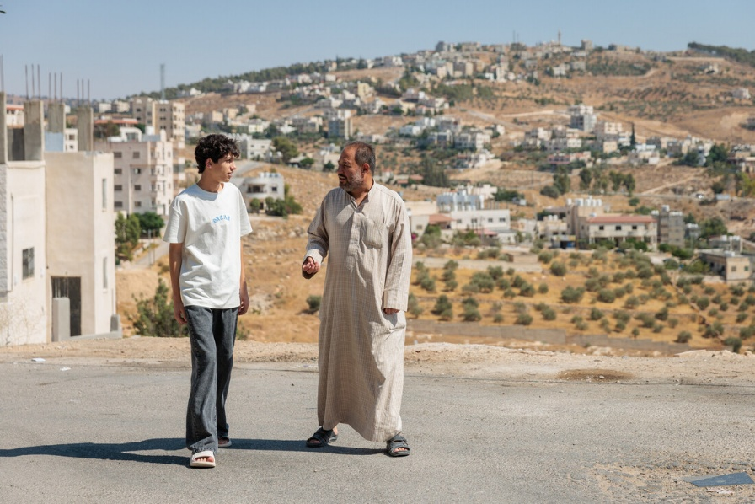
Image credit: Richard Wainwright/Act for Peace. Caption: Abdullah and his son Hamzah* are hoping for a brighter future.
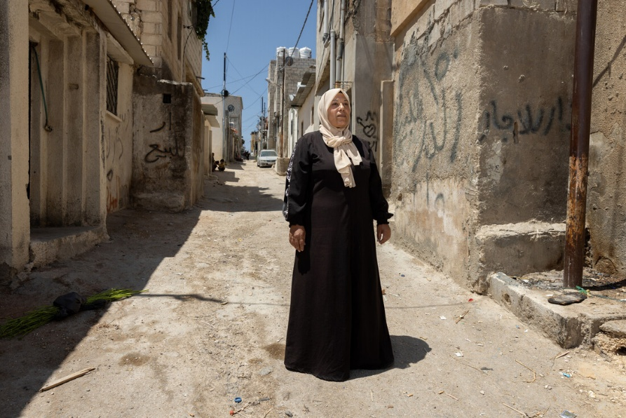
Image credit: Richard Wainwright/Act for Peace. Caption: Palestinian refugee Nidal has built a new life for her family.
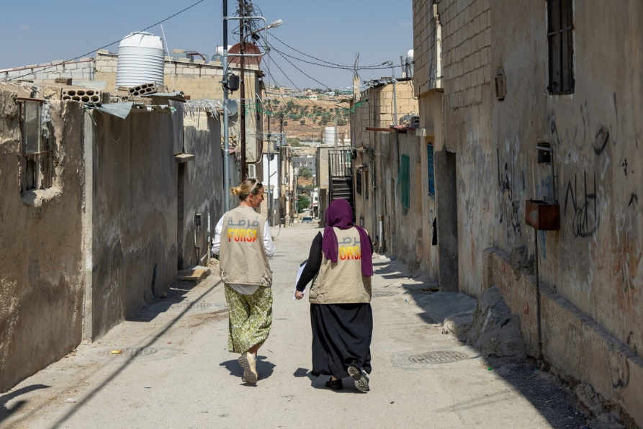
Image credit: Richard Wainwright/Act for Peace. Caption: Walking through the streets of Gaza refugee camp in Jerash, with DSPR staff member, Safaa Al-Khateeb.

