Justice for people seeking asylum and refugees
June 2026
“As Christians called to love our neighbour, welcome the stranger, challenge unjust systems and offer refuge and care to those who are marginalised and in exile, we have a particular responsibility in our society when it comes to responding to issues related to asylum seekers and refugees.”
Shelter from the Storm - A Uniting Church in Australia Statement on Asylum Seeker & Refugee Policy, 2015

“For I was hungry, and you gave me something to eat; I was thirsty, and you gave me something to drink. I was a stranger, and you invited me in.” Matthew 25:35.

Number of Refugee Places
The number of refugees worldwide has continued to increase. The number of refugees increased from 8.5 million in 1980 to 31.6 million in 2023, 38 million in 2025 and 42.5 million in February 2026.

The Labor Party had promised to increase Australia’s refugee intake to 27,000, with an additional 10,000 places through complementary pathways, such as those sponsored by Australian community groups. The Labor Government did increase the refugee intake to 20,000 in the 2023-2024 financial year, but has not increased it further. There are several Commonwealth Government pilots which are, or could become, complementary pathways to settlement for refugees. These pilots are the Skilled Refugee Labour Agreement Pilot, the Refugee Student Settlement Pathway Pilot and the Community Refugee Settlement and Integration Program.

Every resettlement place offered by the Australian Government is now more critical than ever.

Resettlement provides vital, life-saving solutions for refugees and tangible support to countries that host many refugees. It provides hope and practical alternatives to refugees who may otherwise see dangerous onward journeys as the only way out of unsustainable situations in which they and their families are at significant risk.

The Slow Lane of the Fast Track Policy
In December 2014, the Australian Government changed how it determined the refugee claims of people who arrived in Australia by boat. The Government called the new process 'fast tracking'.

The 'fast track' policy removed a fair review process for asylum applications and imposed very short timeframes for lodging applications. The Government of the time also cut 85% of the funding for legal services to assist people with applications for protection. Hence, people often had to lodge their applications without legal advice or support.

'Fast tracking' replaced the previous independent merits review system with a new body called the Immigration Assessment Authority (IAA). The IAA did not hold hearings to gather evidence from the person claiming asylum. It was generally restricted to assessing information provided by the Department of Immigration. It could only consider new information in 'exceptional circumstances', such as evidence of 'significant torture and trauma', which would have affected the consideration of the asylum claim.

The now-abolished fast-track process did not provide a proper review process. As a result, there is a higher risk of people needing protection being returned to the country they fled to face persecution.

People who were processed through the fast-track system continue to live on short-term visas that need to be renewed every three to six months. Many can’t study or access secure work. They can’t reunite with their families.

The Australian Churches Refugee Taskforce has joined with Common Grace and the National Council of Churches Australia in a campaign #EndTheWaiting. The campaign is calling for a clear pathway to permanency for those stuck in the Fast Track process, and for a single, stable bridging visa until their asylum claims are resolved. More details about the campaign can be found at https://www.endthewaiting.com/

Keeping People Seeking Asylum out of Destitution
Changes to the Status Resolution Support Services (SRSS) Program since 2017 have contributed significantly to an increase in destitution and homelessness among people seeking asylum in Australia. The Program provides minimal essential assistance to people seeking asylum, including payments set at 89% of the JobSeeker rate. Funding for the Program has been cut by 91% since 2017. The number of people assisted by the Program has decreased from 29,000 in 2015 to 1,916 in June 2025. Charities cannot meet the need for emergency assistance among people seeking asylum who are not eligible for SRSS Program payments. Homelessness services are reporting an increase in the number of people seeking asylum who are sleeping on the streets. Forcing people into situations of destitution is proving to be counter-productive to efforts to resolve their asylum claims.
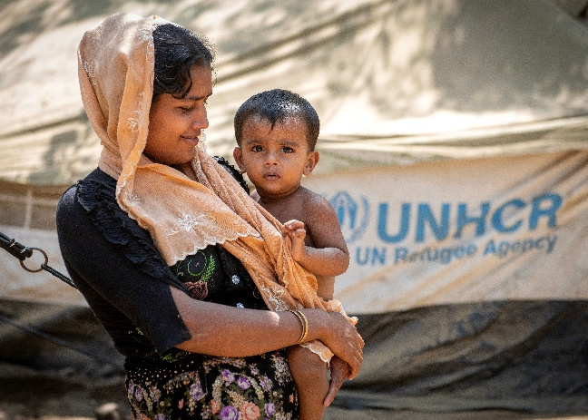
What You Can Do
Write polite and respectful letters to:

The Hon Tony Burke MP
Minister for Immigration and Citizenship
PO Box 6022
House of Representatives
Parliament House
Canberra ACT 2600

Salutation: Dear Minister

Points to make in your letters:
- Express concern at the growing number of refugees globally who need resettlement.
- Urge that the Government follow through on its commitment to increase the refugee intake to 27,000 people a year, with an additional 10,000 places through complementary pathways such as local communities sponsoring refugees to resettle, refugee places linked to employment offers and family reunion.
- Request that the Australian Government provide a pathway to permanent residency for people previously rejected through the fast-track process.
- Request that the Government grant permanent visas to the approximate 700 people who were held on Nauru or PNG and are now in Australia, but do not have another country to be resettled in.
- Ask that the Australian Government expand the eligibility criteria of the Status Resolution Support Services Program to ensure people seeking asylum who are in crisis get access to the basic support they need to stay engaged in the process to resolve their asylum claim. The Program should prevent people seeking asylum from falling into destitution.

Photo Credit: Richard Juilliart/ Shutterstock.com

