Worship Service resources for
The Week of Prayer for Christian Unity

and throughout the year

2026

“There is one body and one Spirit, just as you were called
to the one hope of your calling”

(Ephesians 4:4)

Jointly prepared and published by
Dicastery for Promoting Christian Unity
Faith and Order Commission of the World Council of Churches
‘Adapted for use in Australia by an ecumenical group appointed by the NCCA’.

ECUMENICAL WORSHIP SERVICE

Light from light for light

Introduction

It is an honour for the Armenian Apostolic Orthodox Church to be highlighted during this year’s Week of Prayer for Christian Unity. We are happy to share with our Christian brothers and sisters around the world an ecumenical service that comes from the heart of our church’s ancient Christian witness to the Lord Jesus Christ.
The title of the service, Light from Light for Light is inspired by the attribute of Christ adopted by the Nicene-Constantinopolitan creed, the monumental touchstone of all Christians, whose 1700th anniversary we commemorated last year. Christ is ‘Light from the Light’. But the Anointed One was sent into this world with a mission: to shine God’s Light into this troubled world, and to bring us into loving communion with each other and with God. Thus, ‘Light from Light for Light’.
This service is adapted from the ‘Sunrise Service’, one of the daily prayer-hours of the Armenian Church, which was compiled by the great Catholicos (ie patriarch/leader of the Church), the theologian, hymnographer, liturgical reformer, ecumenist and pastor, St Nersess ‘the Gracious’ of Gla (†1173). It is significant that St Nersess composed this service, which has no counterpart in any other church, with a specifically ecumenical intent: to return to Christ’s embrace a sect of sun-worshipping pagans who were circulating in Armenia during his time. The imagery of Christ the Light suffuses the prayers, hymns and Scripture readings of the service and surely would have attracted the interest of the sun-worshippers. St Nersess sought out the lost sheep not through intimidation, nor by negotiation, but through a creative and loving offering of the very best his church’s Christian witness had to offer. Perhaps this can serve as a model for all of us who strive for the Christian communion desired for us by God.
It is also noteworthy that Armenia became the first nation to declare Christianity as its official religion, through the efforts of St Gregory when he converted the pagan King Trdat in the year 301AD. St Gregory is known as ‘the Illuminator’ because he brought the Light of Christ to the Armenian people through baptism of the Holy Spirit in the name of the Holy Trinity.
The faithful of the Armenian Church are grateful for the prayers of all of the churches during this year. May the Holy Spirit open our hearts wide to perceive more vividly the radiant light of Almighty God’s love for his children, the grim disgrace of our division, and the blazing urgency for us to rekindle the light of Christian reconciliation, as we thank God always for the boundless compassion and mercy of the ‘Light from Light’.
The texts assigned to the leader (L) may be shared between the various clergy or representatives from the different traditions present. Likewise, texts assigned to a reader (R) may be distributed among several individuals. Where particular elements of the service call for two readers, this is indicated by R1 and R2.
Following the prayer after the sermon/homily, the two sides of the assembly recite or chant verses of Psalm 97 alternately, with all joining together on the response. As the psalm is being recited/chanted, candles are distributed to the people. The candles are lit during the hymn which follows, and all join in reciting the Nicene Creed.

MUSIC FOR THE ‘LIGHT FROM LIGHT FOR LIGHT’ SERVICE

While local assemblies may wish to choose suitable songs familiar in their region, it would be desirable, if possible, to sing the hymn texts from Armenia that are included in the worship service. The three hymns can all be sung to a simple melody which can be found in the appendix. The hymn during the lighting of the candles also features a short refrain before each verse – a single word, Looys, which means light in Armenian. The melody is included in the service and assemblies are encouraged to include it when celebrating this worship service.

Additional hymns for use on the theme of light during the liturgy

TOGETHER IN SONG (TIS)
Choices will need to be made depending on the time of day the service is held – morning or evening- and reflecting the scope of traditions present.
181 Come, God of all the earth
183 Sing of the Lord’s goodness
191 Hail gladdening Light
193 God, you are clothed with light
212 Christ, whose glory fills the sky
238 Christ is the worlds’ true light
246 Christ is the world’s light, he and none other
392 At the dawning of salvation
548 Eternal light, shine in my heart
558 All praise to thee, my God this night
582 Lead kindly light, amid encircling gloom
643 I want to walk as a child of the light
666 We are marching in the light of God
725 In our darkness, there is no darkness. Taize chant
747 The Lord is my light and salvation Taize chant
752 Veni sancte Spiritus. Taize chant
780 May light come into your eyes

Also, Christ be our Light by Bernadette Farrell (not in TiS)

Other sources of music for Christian Unity
NEW ENGLISH HYMNAL
480 In Christ there is no East or West
481 Jesus, Lord, we look to thee
481 The Church’s one foundation
485 Thy hand, O God, has guided

https://www.carolynshymns.com/topical_index.html (scroll to Ecumenism-Christian Unity)

Scripture quotations: The scripture quotations contained herein are from The New Revised Standard Version of the Bible, copyright © 1989, 1995, by the Division of Christian Education of the National Council of the Churches of Christ in the United States of America and are used with permission. All rights reserved.

Order of worship

Light from light for light

L Leader
R Reader
A Assembly
C Choir or Cantor

The Lord’s Prayer
L Blessed is our Lord Jesus Christ. Amen.

A Our Father who art in heaven, hallowed be thy name.
Thy kingdom come.
Thy will be done on earth as it is in heaven.
Give us this day our daily bread
and forgive us our trespasses as we forgive those who trespass against us. And lead us not into temptation but deliver us from evil.
L For thine is the kingdom and the power and the glory for ever and ever.
A Amen.

Invocation
R1 May the name of the Lord be blessed forever, for his name is before the sun.

R2 All the nations of the earth will be blessed through him and all generations will extol him.

R1 Blessed is the Lord God of Israel, the only worker of wondrous deeds, the holy name of his glory is forever blessed. The whole world will be filled with his glory.
A Amen! Amen!

R2 Glory to the Father and to the Son and to the Holy Spirit. R1 Now and always and unto the ages of ages.
A Amen.
R2 Again in peace let us beseech the Lord. Heed our prayers, raise us to life and have mercy on us.

L Blessing and glory to the Father and to the Son and to the Holy Spirit.
Now and always and unto the ages of ages.

A Amen.
Psalm 72:15-18

Hymn of Light

As the hymn is being sung, a large candle is lit in the front of the church.

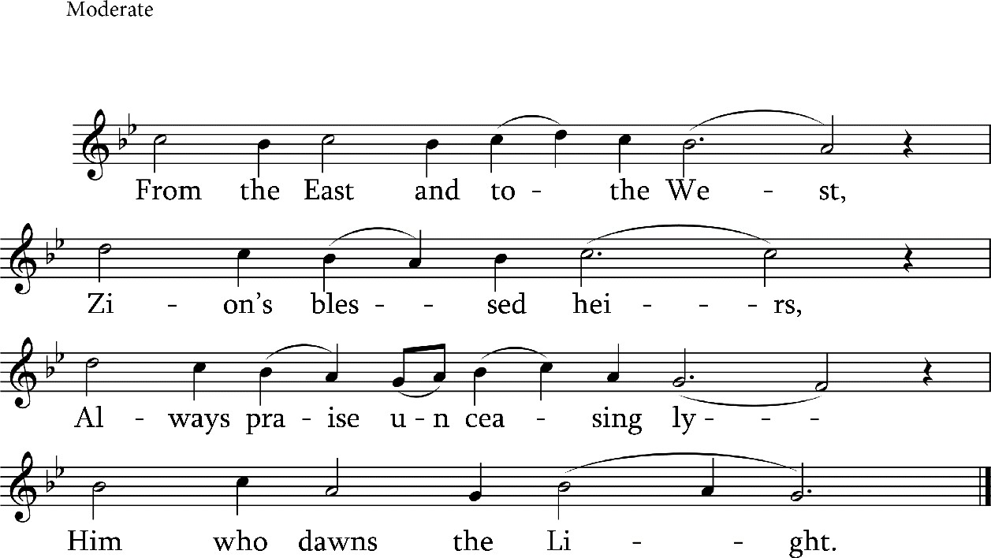

C/A From the East and to the West,
Zion’s blessed heirs, Always praise unceasingly Him who dawns the Light.

Churches of the righteous ones, All who honour him,
Glorify the One who gave Meaning to the light.

St Nersess the Gracious

Litany
R From Sunrise in the East to Sunset in the West, and throughout the entire Christian world, wherever people call on the name of the Lord in holiness – by their prayers and intercession may the Lord have mercy on us. Let us beseech God to deliver us from sin and from the temptations of the world. May the Lord accept the vows and supplications of our hearts and count us worthy of his faith and his commandments together with all of his saints. Almighty Lord our God, raise us to life and have mercy on us.
A Raise us to life, O Lord.

R (If celebrated in the morning)

That the Lord may usher forth this sunlit morning and guide the day ahead in peace; with faith, let us beseech the Lord.
or
(If celebrated in the evening)
That the Lord may usher forth this coming evening and the night ahead in peace; with faith, let us beseech the Lord.
A Grant it, O Lord.
R For an angel of peace to be our guardian, let us ask the Lord.
A Grant it, O Lord.

R For the pardon and forgiveness of our transgressions, let us ask the Lord.
A Grant it, O Lord.
R For the great and mighty power of the holy Cross to help us, let us ask the Lord.
A Grant it, O Lord.
R Once again, for our true and holy faith, all together, let us beseech the Lord.
A Lord, have mercy.
R Let us commit ourselves and one another to the almighty Lord our God.
A We commit ourselves to you, O Lord.
R Have mercy on us, Lord our God, in your great mercy. Let us all say together as one:
A Lord, have mercy. Lord, have mercy. Lord, have mercy.

Prayer and sharing the peace
The Leader may face East for the following prayer, which is prayed with arms outstretched:

L From Sunrise in the East to Sunset in the West, blessed are you, O Lord, because you are King, and your name is revered throughout the universe. Let our psalmody resound sweetly in your hearing. Let justice dawn from your righteousness and rise over our frailty, and may your most holy name be glorified. Let us become worthy to abide by your commandments and to sing praise and glory to the Father and to the Son and to the Holy Spirit, now and always and unto the ages of ages.

A Amen.
The Leader faces the people and may make the sign of the Cross, while saying:
L Peace to all.
A And with your spirit.

The people may exchange a suitable greeting of peace.

R Let us bow down to God.

The people bow down to God in worship, saying:

A Before you, O Lord.
The Leader may turn to the East and prays again, saying:

L Everlasting God, Eternal God, you dawned as light in this world and you illumined us from the darkness of our sin. Infinite God, you came into our finite existence, abundantly pouring out the gifts of the Holy Spirit on your creatures. Now and for all eternity you are extolled, most great God, with the Father and the most Holy Spirit, now and always and unto the ages of ages.
A Amen.

Scripture readings
R1 This reading is from the Prophet Isaiah (58:6-11)

Is not this the fast that I choose: to loose the bonds of injustice, to undo the thongs of the yoke, to let the oppressed go free, and to break every yoke? Is it not to share your bread with the hungry, and bring the homeless poor into your house; when you see the naked, to cover them, and not to hide yourself from your own kin? Then your light shall break forth like the dawn, and your healing shall spring up quickly; your vindicator shall go before you, the glory of the Lord shall be your rear guard. Then you shall call, and the Lord will answer; you shall cry for help, and he will say, Here I am. If you remove the yoke from among you, the pointing of the finger, the speaking of evil, if you offer your food to the hungry and satisfy the needs of the afflicted, then your light shall rise in the darkness and your gloom be like the noonday. The Lord will guide you continually, and satisfy your needs in parched places, and make your bones strong; and you shall be like a watered garden, like a spring of water, whose waters never fail.

R2 This reading is from the Letter of the Apostle Paul to the Ephesians. (4:1-13)
I, therefore, the prisoner in the Lord, beg you to walk in a manner worthy of the calling to which you have been called, with all humility and gentleness, with patience, bearing with one another in love, making every effort to maintain the unity of the Spirit in the bond of peace: there is one body and one Spirit, just as you were called to the one hope of your calling, one Lord, one faith, one baptism, one God and Father of all, who is above all and through all and in all. But each of us was given grace according to the measure of Christ’s gift. Therefore it is said, “When he ascended on high, he made captivity itself a captive; he gave gifts to his people.” (When it says, “He ascended,” what does it mean but that he had also descended into the lower parts of the earth? He who descended is the same one who ascended far above all the heavens, so that he might fill all things.) He himself granted that some are apostles, prophets, evangelists, pastors and teachers to equip the saints for the work of ministry, for building up the body of Christ, until all of us come to the unity of the faith and of the knowledge of the Son of God, to maturity, to the measure of the full stature of Christ.

C/A (chanted) Alleluia. Alleluia.
For with you is the fountain of life; in your light we see light.
R Alleluia. Rise to your feet.
The Leader faces the people and may make the sign of the Cross, while saying:
L Peace to all.
A And with your spirit.

R Listen attentively to the holy Gospel of Jesus Christ according to John. (12:31-36)
C Glory to you, Lord our God.

R Attention! God is speaking.

Jesus said to the crowd: ‘Now is the judgement of this world; now the ruler of this world will be driven out. And I, when I am lifted up from the earth, will draw all people to myself.’ He said this to indicate the kind of death he was to die. The crowd answered him, ‘We have heard from the law that the Messiah remains for ever. How can you say that the Son of Man must be lifted up? Who is this Son of Man?’ Jesus said to them, ‘The light is with you for a little longer. Walk while you have the light, so that the darkness may not overtake you. If you walk in the darkness, you do not know where you are going. While you have the light, believe in the light, so that you may become children of light.’

C/A Glory to you, our Lord Jesus Christ.

Sermon/Homily Prayer
R Gracious Lord, God of all,
Guide for the lost, Light for those in darkness. Our eyes turn to you, hear our prayers.
May the sun of your glory shine forth, giving life and light to all, from the East to the West, and from the North to the South. Let the morning rays of your eternal spring awaken us who await your coming.

O Jesus Christ, Light from the Light, dwell within us, who have come together to worship your holy and precious name. Let your life-giving radiance kindle within us a deeper love for one another. May your brilliant light stir us to ever more flourishing unity. Like diverse flowers in the garden of your Kingdom, may your divine brilliance cause us to bloom in harmony. And so, all as one, may we always joyfully praise and glorify you, and the Father and the Holy Spirit, now and always and unto the ages of ages. Amen.
Adapted from St Gregory of Narek

Responsorial psalm
The two sides of the assembly recite or chant verses of the psalm alternately, with all joining together in the response. As the psalm is being recited/chanted, candles are distributed to the people.
R Our eyes turn to you, O God of all. Have mercy on us and hear our prayers.
A Our eyes turn to you, O God of all. Have mercy on us and hear our prayers.
Side1 The Lord is king. Let the earth rejoice; let the many coastlands be glad!
Side2 Clouds and thick darkness are all around him; righteousness and justice are the foundation of his throne.
A Our eyes turn to you, O God of all. Have mercy on us and hear our prayers.

Side1 Fire goes before him,
and consumes his adversaries on every side.
Side2 His lightnings light up the world; the earth sees and trembles.
A Our eyes turn to you, O God of all. Have mercy on us and hear our prayers.

Side1 The mountains melt like wax before the Lord, before the Lord of all the earth.
Side2 The heavens proclaim his righteousness; and all the peoples behold his glory.
A Our eyes turn to you, O God of all. Have mercy on us and hear our prayers.

Side1 All servants of images are put to shame, those who make their boast in worthless idols; all gods bow down before him.
Side2 Zion hears and is glad, and the towns of Judah rejoice, because of your judgments, O God.
A Our eyes turn to you, O God of all. Have mercy on us and hear our prayers.

Side1 For you, O Lord, are most high over all the earth; you are exalted far above all gods.
Side2 You who love the Lord, hate evil; he guards the lives of his faithful; he rescues them from the hand of the wicked.
A Our eyes turn to you, O God of all. Have mercy on us and hear our prayers.

Side1 Light dawns for the righteous and joy for the upright in heart.
Side2 Rejoice in the Lord, O you righteous, and give thanks to his holy name!
A Glory to the Father and to the Son and to the Holy Spirit.
Now and always and unto the ages of ages. Amen.
Psalm 97

Hymn

While the hymn is being sung, two young people holding unlit candles or tapers light them from the central candle and the light is passed to all in the church.
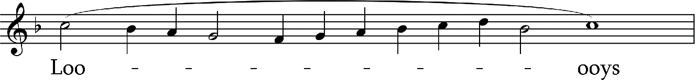

Ageless, uncreated God, Father, Lord of all;
Heed our prayers, the earnest pleas Of those serving you.

From the Father, wondrous Dawn, Just and righteous Sun;
Rise, shine forth upon us all Kind and tender Light.

Spirit pouring from the Fath’r,
Wellspring of the good;
Fill us with your rad’iant Light
In this new day’s morn.

Persons three, in nature one, One Divinity;
We confess you at all times –
Holy Trinity.

St Nersess the Gracious

Creed

L Bathed in the light of the Wisdom of Christ, together, let us confess our common faith.

A We believe in one God, the Father, the Almighty,
maker of heaven and earth,
of all that is, seen and unseen.
We believe in one Lord, Jesus Christ, the only Son of God,
eternally begotten of the Father, Light from Light,
true God from true God, begotten, not made;
of one Being with the Father. Through him all things were made.
For us all, and for our salvation he came down from heaven;
and was incarnate of the Holy Spirit and the virgin Mary, and was made human.
For our sake he was crucified under Pontius Pilate; he suffered and was buried.
On the third day he rose from the dead in accordance with the scriptures.
He ascended to heaven
and is seated at the right hand of the Father.
He will come again in glory
to judge the living and the dead and his kingdom will have no end. We believe in the Holy Spirit,
the Lord, the giver of life,
who proceeds from the Father.
Who, with the Father and the Son, is worshipped and glorified, who has spoken through the Prophets.
We believe in one, holy, catholic and apostolic Church. We confess one baptism for the forgiveness of sins.
We look forward to the resurrection of the dead, and to life in the age to come. Amen.

Closing prayers

L Again, in peace, let us beseech the Lord.
Let us glorify Almighty God, who has shined his light upon his creatures. Now, may he once more shine his abundant mercy upon those who glorify his name in song. Almighty Lord our God, raise us to life and have mercy on us.

A Lord, have mercy. Lord, have mercy. Lord, have mercy.

L Gracious and almighty Lord Jesus Christ, Son of God, you are the true Light, who cast out the darkness of sin, and shines into our hearts the joy and hope of your eternal Kingdom.

A Lord, have mercy.
L Loving Lord, accept the prayers of all your faithful children throughout the world, who call out to you with one mind, one voice, and one heart. Through your beloved disciple John, you promised that if we walk in your light, then we will have communion with one another, and your precious blood will cleanse us of all sin. Bring us that blessed communion, O Saviour!
A Lord, have mercy.

L Grant us peace, O Loving Lord, and remove the scourge of civil unrest and violence from the face of the earth. Change the hearts of all who make war and touch the wounds of all who are afflicted by war. Comfort all prisoners of war and speedily bring them home. Let the light of your love shine in all the dark places of our world and hasten the day when all peoples may dwell in peace with justice.

A Lord, have mercy.

L O Refuge and Shelter, Lord Jesus Christ, look with compassion on refugees throughout the world, who suffer the agony of displacement and the loss of their homes. Move us to manifest our communion with you, with them and with each other through gestures of hospitality and loving help.

A Lord, have mercy.

L O Christ, our Saviour, we pray for the people of Armenia and Artsakh, and their kindred throughout the world, who long ago turned to your light through the preaching of the Apostle Thaddeus and the miraculous witness of St Gregory the Illuminator.

A Lord, have mercy.

L Shine the light of your righteousness and wisdom on all your creatures. Make us children of light and children of the day, so that we may always live our lives reverently, and become for all the world, worthy lampstands for your life-giving light.

A Lord, have mercy.

L For you are our Saviour, and to you be glory, dominion and honour, now and always and unto the ages of ages.
A Amen.

Hymn

Moderate
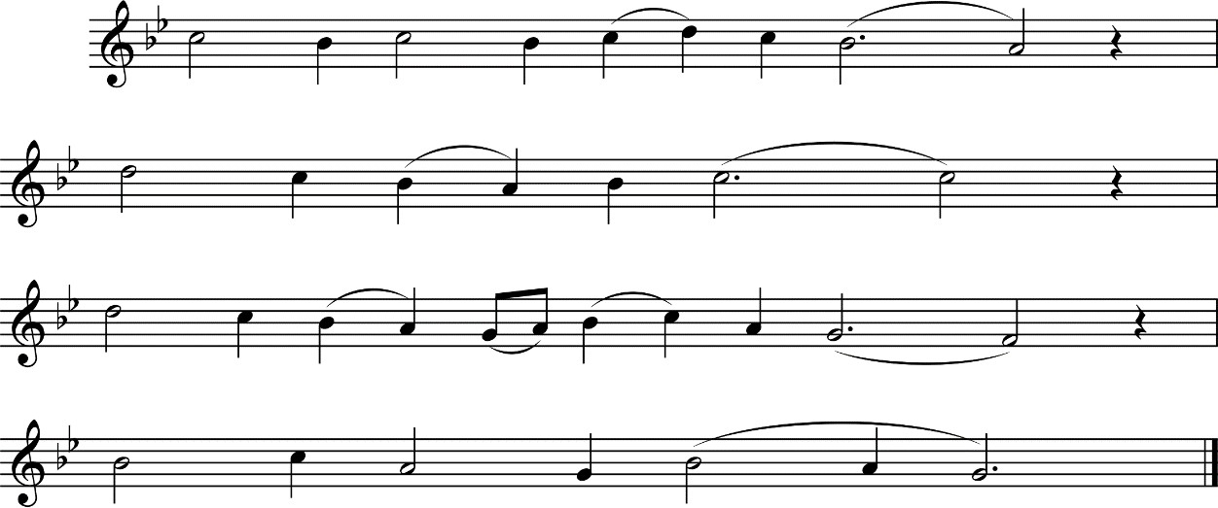

C/A Christ, the good and gracious Way, And the living Truth.
Leader of our spirits from
Earth to heav’n above.

Jesus, Door to Life, True God, Through you we shall come; Now admit us to your Father, By your Holy Spirit.
St Nersess the Gracious

The Lord’s Prayer

L Blessed is our Lord Jesus Christ.

A Amen.

A Our Father who art in heaven, hallowed be thy name.
Thy kingdom come.
Thy will be done on earth as it is in heaven.
Give us this day our daily bread
and forgive us our trespasses as we forgive those who trespass against us. And lead us not into temptation but deliver us from evil.
For thine is the kingdom and the power and the glory forever and ever. Amen.

L The grace of our Lord Jesus Christ, and the love of God, and the communion of the Holy Spirit be with you all.
A Amen.

