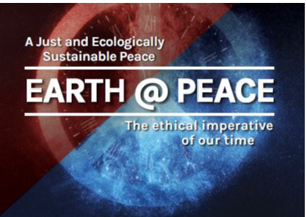
A timely project for a just and ecologically sustainable peace
UPDATE 2 JANUARY 2019
About the Project
Ours is the age of turbulence. Climate change is now an existential threat, and so are nuclear weapons. Then we have the long list of armed conflicts, terrorism and the war on terror, rising inequalities of wealth and income, ethnic cleansing and genocide. massive refugee flows and spiralling environmental crises. Adding insult to injury is the rising tide of mindless nationalism, xenophobia, and populist extremism.
But there are promising signs. A treaty to ban nuclear weapons is in the making. Those working for it won the 2017 Nobel Peace Prize. Regardless of government policies, a new ecological consciousness is taking root in most parts of the world, while in virtually every country action on climate change is under way. And on many other fronts we see evidence of greater awareness and a renewed willingness to act.
One of the more inspiring developments over the last 20 years is the fledgling movement calling for a shift from ‘Just War’ to ‘Just Peace’. It is clearly time to question the just war tradition that has informed theology, ethics more generally and international law for the last several centuries.
This project, sponsored by a wide range of organisations and individuals, is part of that movement. It heralds a new approach to peace ― a deeper understanding of safety and security.
To be safe is to be free of injury, to be healthy, to be whole. The absence of war and other physical violence is not enough. Poverty, humiliation, discrimination also injure and maim. And it is not just those who are living now that need protection, but future generations and all living species.
The peace we envision is one that is both just and ecologically sustainable – a peace that responds to the cries of the poor, and the cries of the Earth.
Easier said than done, you may think. Our aim is ambitious yet modest. This project explores new directions, new ways of thinking and acting, by placing the focus on Australia. It seeks to create new opportunities for Australians to engage in an emerging a global conversation. The task is demanding yet doable.
A conversation informed by the notion of just and ecologically sustainable peace can help us rethink:
- the relationship between Indigenous and non-Indigenous Australians
- the way we shape our economy and environment
- our long-standing dependence on imperial power, military alliances, and the use of force
- our engagement with the peoples of Asia-Pacific and the diverse cultures and faiths that make up contemporary Australia.
How does the project do this? Through a multifaceted program of dialogue, educational and cultural events that will flesh out a new approach to peacemaking and peacebuilding as an alternative to just war thinking.
The highlight will be the landmark Conference Earth@Peace to be held on 23-24 April 2019

What has happened so far
Lead-up event on Remembrance Day (11 November 2018)
We made a positive start, with excellent contributions by speakers and poets, attended by some 80 people, with another twenty who had booked but could not make it. Of those present, some 40 people agreed to become 'Friends of the Earth@Peace Project'.
Four-Page Pamphlet
A four-page pamphlet From Just War to Just Peace has just been published. It sets out the failings of just war thinking and the promise of a just and ecologically sustainable peace. It also points to some of the hard intellectual and practical issues that need to be addressed if the shift to just peace thinking is to gain momentum in the coming months and years. Both the printed and electronic versions are available on request.
Conference program
Most parts of the varied and packed program for the April Conference are finalised, including 3 keynote speakers, 14 other presenters, 7 working group facilitators, and ten participants in a hypothetical - all of them distinguished contributors in their respective fields of inquiry and civic engagement. There are a few remaining slots which we expect to fill in the next 3 or 4 weeks.
Crowdfunding
A crowdfunding campaign was launched in November 2018 to help cover the costs of the April Conference, including a few scholarships enabling Indigenous Australians, Pacific Islanders, refugees residing in Australia and university students to participate in the Conference. We set an initial target of $8,500, and a desirable higher target of $11,750. We ended up with a total commitment of $15,300. After covering various charges and fees, we have received a net amount of just over $14,200. We are delighted with the result, and thank everyone for their generous contributions.
Sponsoring and supporting organisations
As of now the list includes:

Centre for Research in Religion and Social Policy (RASP), University of Divinity
Pax Christi
Social Policy Connections
Trinity College Theological School
Australian Research Theology Foundation Inc
Ethos
Australian Association of the Study of Religions
Borderlands Co-operative
Christian Brothers
Faith Communities Council of Victoria
Global Reconciliation
Islamic Council of Victoria
Loreto Sisters
Melbourne Unitarian Peace Memorial Church
PaCSIA - Peace and Conflict Studies Institute Australia
Redemptorist Congregation
Religions for Peace
Victorian Council of Churches
Society of Friends, Victorian Regional Meeting

Coming Months
Landmark Conference (23-24 April)
The Conference is open to all who care for the Earth and humanity’s future, this highly interactive Conference will comprise:
- Presentations by leading experts setting out their perspectives on a ‘just and ecologically sustainable peace’ – they include Professor Heather Eaton (Canada), Professor Chaiwat Satha-Anand (Thailand), Professor Bruce Pascoe (Indigenous Australian);
- Interviews and panel discussions with other leading thinkers;
- Working Groups addressing some of the most crucial questions we face, leading to concrete recommendations for consideration by the whole conference;
- A discussion involving 12 leaders and experts, using a "hypothetical" format, who will be asked to consider the ethical and practical implications of an Australian government attempting to apply the principles of a just and ecologically sustainable peace to our foreign and security policies.

Conference Bookings here www.trybooking.com/book/event?eid=432955&

Closing date for Early Bird registrations: 23 February

Conference Scholarships
- Up to ten (10) scholarship are being offered by Pax Christi. Each scholarship will cover the cost of registration for the two days, including the two evening public events.
- Those eligible to apply are: Indigenous Australians; Pacific Islanders residing in their home country; refugees and asylum seekers currently resident in Australia; full time Australian students currently completing an undergraduate or postgraduate degree; young Australians aged 20 to 35 on low incomes
- New Closing date of applications: Friday 1 March 2019
For application form and further details contact Pax Christi Secretary: camrita44@gmail.com.
Public Forum (23 April)
For the evening we are thrilled that the two international keynote speakers will be joined by Behrouz Boochani, outspoken Kurdish-Iranian writer and advocate, detained on Manus Island since 2013, author of the widely acclaimed No Friend but the Mountains.
General Admission: $20 (concession: $15). Entry is by cash on the night.
Cultural Evening (Anzac Day eve, 24 April)
The event will feature a fascinating combination of poetry, singing, music and performance around the themes canvassed at the conference. The event is open to the public. Bookings:
General Admission: $10. Entry is by cash on the night.
Art Exhibition
Leading peace artist, William Kelly, who has an international reputation, has kindly agreed to exhibit his work (some of it in collaboration with others, including Indigenous artists) as part of the Earth@Peace project. The exhibition titled Just Art will be hosted at CTM. It will be launched on 23 April and run to 7 June. This is another important element of the project, combining the visual arts with the spoken and written word, to communicate new ways of understanding and engaging with the journey to a Just and Ecologically Sustainable Peace.

Feature Film
William Kelly's Big Picture
to be released mid-year
Special Showing for Earth@Peace with William Kelly in attendance
Details TBC
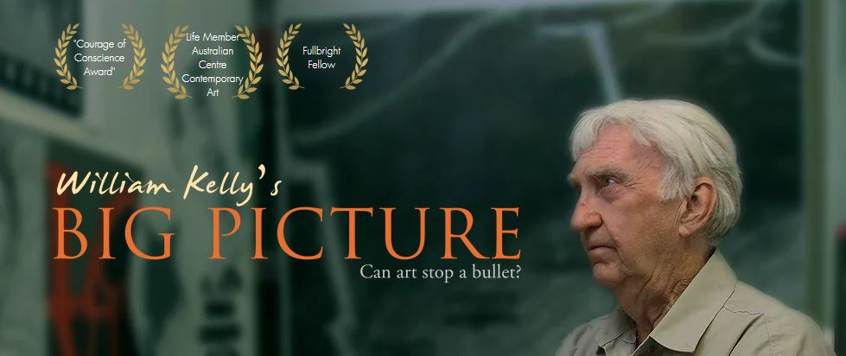

Other events
- A book with a leading international publisher aimed at the academic and policy-making communities
- An attractive publication accessible to a wider public, featuring art, poetry and short essays based on the themes of the conference.
- A book launch for both publications
- An intensive one-day workshop for teachers and educators presenting a model teaching and learning program around the notion of ‘just and ecologically sustainable peace’.
Details TBC

