Shared lunch and forum with religious and faith groups
with Sister Patricia Fox SND

St Marys Church Erskineville, 21 Swanson St, Erskineville
(street parking is limited – the best way to come is by train to Erskineville Stations. 2 minute walk)

Saturday December 1, 2018 from 12:30 – 3.30 pm

Shared light lunch and chatting 12.30 to 1.15pm Very important: Please RSVP and invite people to come.
Bring food to share if you can.
2. Liturgy 1.20 to 1.30pm
3. Presentation by Sr Pat 1.30 to 2.00pm
4. Q and A – Open Forum

Saturday December 1, 2018 12.30 pm to 3.30pm

A shared light lunch will be followed with a presentation by Sister Patricia on her experience in the Philippines and the relationship between faith, rights and human dignity to be followed by an open Q and A forum.
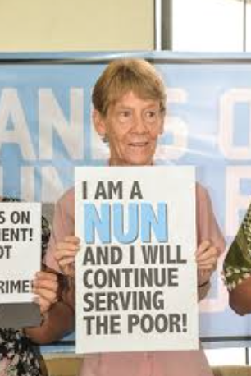
Sr Patricia Fox, superior of the Our Lady of Sion congregation in the Philippines, was forced to return to Australia on November 5, 2018 after living amongst and serving the people of the Philippines for 27 years. The Government of the Philippines accused her of ‘political action’ not ‘missionary work’ when she spoke up for the poor and human rights.

Many people - lay persons, individual religious people and congregations – joined in an enormous petition of support for Sister Pat earlier in the year. Come and show your continuing support for her and for the many human rights defenders in the Philippines who continue to be oppressed.

Claude Mostowik msc
Email: mscjust@smartchat.net.au
Mobile: 0411450953

