Week of Prayer for Christian Unity
28 May – 4 June, 2017
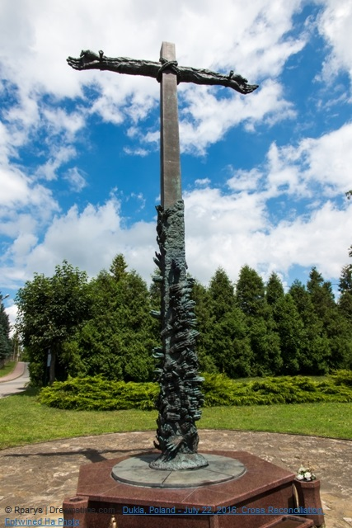

Reconciliation – The Love of Christ Compels Us”
(cf 2 Corinthians 5:14-20)

