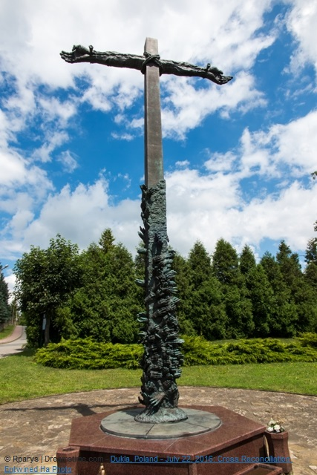
WEEK OF PRAYER FOR CHRISTIAN UNITY
28 May – 4 June, 2017
Sermon Notes
These sermon notes are based on the biblical text from Ezekiel 36:25-27, 2 Corinthians 5:14-20 and Luke 15:11-24.
The following dot points are presented in the hope that the preacher may find something to spark the imagination. Only the local preacher will know the local situation well enough to take these universal ideas and allow them to be interrogated by the experience of the congregation and then in turn to allow the texts to interrogate the local congregation.
- The material this year has been produced by the churches of Germany, the central European region that witnessed the second major divide within Christian history and whose current social and political form owes much to the events of the 15th century.
- Every society evidences a number of significant internal differences of a political, social and religious nature. When people meet and differences are recognized, the result can be mutually beneficial or destructive. The meeting can to an opportunity for complementarity and a greater unity for the benefit of all. Where this is the case, trust is evident and an exercise of power that brings people together and creates possibilities that are mutually enriching. The encounter however can also result in differences being seen as a threat. Where this occurs there is an exercise of power that divides and separates and fear becomes the great motivator.
- Sadly, this tendency to fear and division has become evident in the socio-political language of the 20th century; the expressions ‘iron curtain and ‘bamboo curtain’ became commonplace designations that symbolically divided our planet.
- Over the centuries in what is now Germany, this approach to differences has prevailed too often and has resulted in lack of cooperation and separation that has limited and destroyed people. In the 1930’s Europe was ravaged by the policies of the National Socialist Workers Party in Germany with millions being rejected and separated into groups, deemed unacceptable because of their politics ethnicity, religion, or physical and intellectual capabilities. Then in the 1960’s a wall was built in Berlin dividing the city physically and symbolically and remained a symbol of European division for many decades. In 1989 the wall was demolished and it’s destruction resulted in a new sense of hope for a new era of trust.
- Humanity in the past decade however seems to have been easily pushed back in the direction of wall-erection. S for example a massive wall was erected in Israel in the West Bank to maintain strict control over the movement of Palestinian people, and in the recent presidential election campaign in America, one candidate promised to erect a massive wall along the America-Mexico border.
- What do the Bible readings for the week of prayer for Christian unity say to us about differences, divisions and barrier-responses?
- Firstly we must identify brokenness and separation for what it is – the result of fallen human nature. Secondly, we must do all that we can to dismantle barriers built on a foundation of fear. Thirdly we must make a conscious effort to develop a new approach to handling differences so that the meeting of differences becomes an opportunity for cooperation and mutually-enriching life. Finally we must constantly turn to God-in-Trinity, our model of cooperative difference and our strength to live lives of reconciliation.
- Preceding any human reconciliation activity, was the plan that God had from before time to bring all things and people back into fellowship with the divine Trinity. The history of Israel demonstrates God’s determination to overcome every obstacle and remove every barrier that people put between themselves and God. The history of God’s dealing with humanity is the history of reconciliation.
- The reading from Ezekiel speaks to us of the necessary power of God to work in us for reconciliation and to empower the breaking down of barriers. Human beings have through history demonstrated a lack of willingness to repent of inappropriate barrier-building. Any and every effort to remove barriers that separate is inspired by God.
- The reading from 1 Corinthians reinforces this and says that the love of Christ urges us to reconcile, to work with God to remove all that separates people from one another. Paul writes here that when a person is in Christ, they have been reconciled to God and are thus a new creation. Reconciliation is thus a creative activity; not only are people renewed through barrier-breaking activity but something additional is created – a new relationship! People are brought into fellowship with God through Christ, and are made a part of the Church, the body of Christ. The Church is the new creation, the large-scale result of God’s reconciliation action plan.
- Luke in his Gospel records the wonderfully revealing parable of the family separated by the selfishness and immaturity of the younger son. The son returns to the family, and is welcomed home in spectacular fashion by his father. The parable is of course a window into both human and divine nature. All human beings are like both the younger and the elder brother in the story and God is the Father. Both the younger son and the Father are ‘prodigals’; the younger son in his wasteful reckless living and the Father in his overflowing love and forgiveness. Together they break down the wall erected by the younger son.
- We are reminded however that the call to engage in barrier breaking is a never-ending activity. The Gospel story ends with the Father pleading with the elder son to be reconciled with his younger brother. Reconciliation is always a work in progress. Walls between individuals and groups constantly go up and until the end of time the ministry of reconciliation will be the primary agenda of the Church and the Kingdom of God.
- During this Week of Prayer for Christian Unity we are invited to remember this and challenged to recommit ourselves to a life of barrier-breaking..

